Inland Empire Health Plan
Social Skills Assessment Report

Treatment whose sole purpose is vocational or recreationally based is not considered social skills intervention.

- GENERAL INFORMATION:

First Name: |  | Last Name:
Birth Date: |  | IEHP Member ID#:
Present Address:
Parent/Guardian: |  | Phone:
Language: |  | Referral Date:
Report Date: |  | Assessor/Certification:

- PRESENTING CONCERNS:
Write a brief description regarding the presenting concerns and why the Member is seeking services from your agency.

- Social Skills Setting:
The social skills intervention setting for member: Services are to be provided in a conventional setting.

Individual Home Setting | Group Community/Clinic Setting

- SOCIAL SKILLS IDENTIFIED DEFICITS:
The social skills to be addressed are:

Self-Awareness | Decision Making | Conversation Skills | Turn Taking
Self-Management | Self-Control | Sportsmanship | Negotiation
Social Awareness | Emotions/Social Cues | Bullying | Problem Solving
Relationship Skills | Interpersonal Skills | Conflict Resolution | Cooperative Play
Perspective Taking | Theory of Mind | Joint Attention | Executive Functioning
Restrictive Interests | Social-Emotional Reciprocity
Other: _________________
- BACKGROUND INFORMATION:

  - Living Situation-
Within this section describe where and with whom the Member lives (include any custody/visitation orders, childcare arrangements).

  - School Information-
Within this section list the Member’s school information: Grade Level, School placement (e.g., General Education Class, Specialized Academic Support, Autism Program, Mild/Moderate, Moderate/Severe, or Non-Public School), School name, School attendance days and hours, frequency and duration of related services provided by the school district (e.g., Occupational Therapy, Speech Therapy, Physical Therapy, Adaptive Physical Education, Counseling, Nursing, Applied Behavior Analysis).

  - Health and Medical-
Within this section provide the Member’s psychological and medical diagnoses (include when and who provided the diagnoses). Describe the Member’s birth history, major illness, surgeries, hospitalizations, seizure history, allergies, hearing and vision screening results, vaccination, specialized diet, food consumption challenges or sleep difficulties. Include a list of medications and their relevance to behavior services.

  - Current Services and Activities-
Within this section list the weekly frequency and duration of all services funded by insurance (e.g., OT, ST, PT, Social Skills) and Inland Regional Center (e.g., Infant Stimulation, Respite, Adaptive Skills, Day Program). Additionally, include any weekly activities the Member participates in (e.g., Boy/Girl Scouts, Baseball, Basketball, Soccer, Dance/Gymnastics, Art therapy, etc.).

  - Intervention History-
Within this section list the Member’s intervention history. This includes services received during 0-3 (infant program), ABA services received through regional center or private insurance, social recreation/community integration, adaptive skills training, speech therapy, occupational therapy, and physical therapy. (List the weekly frequency and duration, the length of time the Member received the therapy and the provider/agency that provided the services).

- DESCRIPTION OF ASSESSMENT PROCEDURES:

Procedures: | Date and Location: | Person involved (indicate credentials):
Records Reviewed:
Clinical Interview:
1st Member Observation:

Assessment Measures Administered: | Date(s) Administered:
Vineland Adaptive Behavior Scales, 3rd Edition
SSIS Social-Emotional Learning Edition (SSIS SEL)
Social Responsiveness Scale
Social Communication Questionnaire

  - Records reviewed included: Within this section of the report, include any records reviewed (examples: Individual Program Plan (IPP), Psycho-Diagnostic Evaluation (PDE), Early Start Report, Functional Behavior Assessment, Intensive Intervention Progress Report, Individual Education Plan (IEP), etc.). Report title, report date and report author information are required for each document reviewed.

Records reviewed include:
Example:
- Psycho-Diagnostic Evaluation (Report Author, XX/XX/XXXX).

  - Clinical Interview- Within this section the assessor will narrate the date, time, location, and persons involved in the clinical interview. The assessor will write a summary of parental concerns regarding the member’s deficits for social skills intervention, this could include the recommendations for social skills following a Psycho-Diagnostic Evaluation, difficulties getting along with peers and/or delayed social skills.

  - First Member Observation- Within this section the assessor will narrate the date, time, location, and person’s involved in the first observation of the Member. The assessor will briefly describe significant events (e.g., skill observations, direct observation of skill occurrence) pertaining to the Member’s challenging skills.

- ASSESSMENT MEAURES:

Vineland Adaptive Behavior Scales, 3rd Edition

Date Administered: XX/XX/XXXX

Name of Interview: First Name/Last Name, Credentials

Name of Respondent: First Name/Last Name, Relationship

Assessment Summary:
Write a brief narrative about the results and include the following in a paragraph:
- If there are significant differences between what is reported by the respondent to your observations, please note.
- Note the Adaptive Behavior Composite score from last year and any significant changes with the results since the previous year.
- Refer the reader to reference last year’s report for full Vineland scores.

Domain | Standard  Score* | 95% Confidence  Interval** | Age  Equivalent*** | Adaptive  Level****
Communication
Receptive |  |  | 3 years, 5 months
Expressive
Daily Living Skills
Personal
Domestic
Community
Socialization
Interpersonal Relationships
Play and Leisure Time
Coping Skills
Motor Skills
Gross Motor
Fine Motor
Adaptive Behavior Composite

(Insert page break)

SSIS Social-Emotional Learning Edition

Score Profile
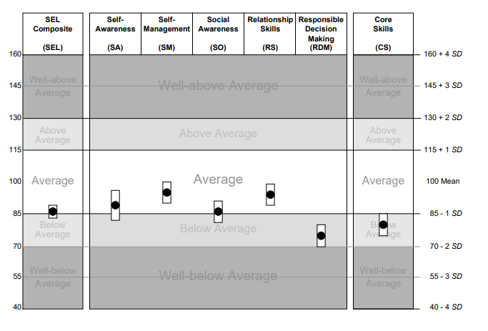

Score Table

 | SEL | SA | SM | SO | RS | RDM | CS
Standard Score
Confidence Interval
Percentile Rank
Raw Score
Response Pattern Index: Raw Score =

(Insert page break)

Social Responsiveness Scale, Second Edition (SRS-2)

Member Information

Member Name | Gender | Age at testing

Rater’s name | Relationship to rated individual

Assessment Information

Examiner’s name | Administration date

Score Profile

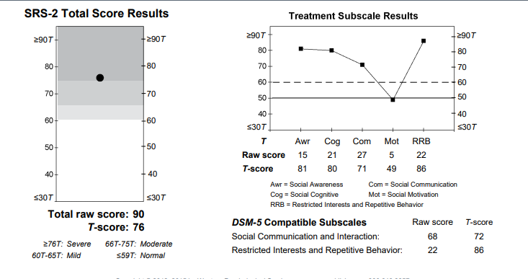

Total Score Discussion

Within this section insert the narrative information about the total score.

(Insert page break)

Social Responsiveness Scale, Second Edition (SRS-2)

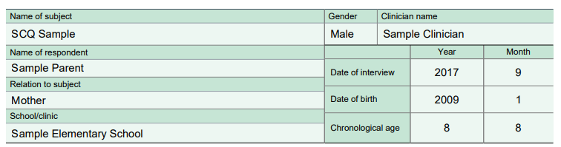

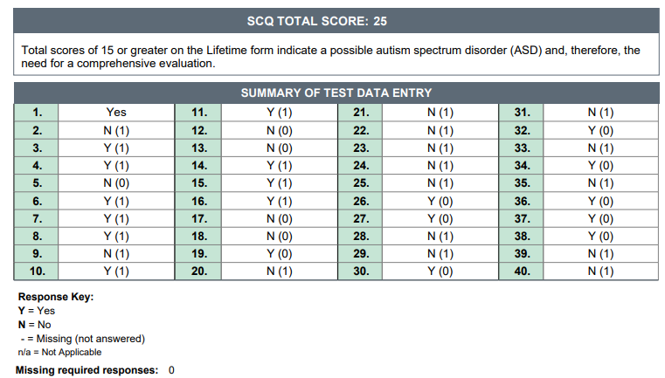

(Insert page break)

- SOCIAL SKILLS GOALS: Goals should be agreed upon by the member and/or guardian (as appropriate), and incorporate the member's perspective on current problems, as well as the member's specific values and preferences (e.g., social significance). The goal should also be developmentally appropriate and based on clinical observation and assessment measure.

- Communication:

- Program Name: Title of program being targeted
Instrumental Goal: (By Date) Objective of the program (make sure this is measurable, objective, and specific)
Data Collection: How data will be collected (e.g., first trial data, rate per hour, percentage of opportunities, partial interval recording)
Mastery Criteria: How you will measure mastery (e.g., 3 consecutive sessions of correct responding)
Generalization Criteria: How you will measure if the skill is generalized (e.g., Across 3 people, 3 settings, and 3 exemplars)
Baseline: Include a brief statement about the Member’s current skill level including a baseline measurement that matches the mastery criteria of the goal.

- Program Name: Title of program being targeted
Instrumental Goal: (By Date) Objective of the program (make sure this is measurable, objective, and specific)
Data Collection: How data will be collected (e.g., first trial data, rate per hour, percentage of opportunities, partial interval recording)
Mastery Criteria: How you will measure mastery (e.g., 3 consecutive sessions of correct responding)
Generalization Criteria: How you will measure if the skill is generalized (e.g., Across 3 people, 3 settings, and 3 exemplars)
Baseline: Include a brief statement about the Member’s current skill level including a baseline measurement that matches the mastery criteria of the goal.

- Social Skills:

- Program Name: Title of program being targeted
Instrumental Goal: (By Date) Objective of the program (make sure this is measurable, objective, and specific)
Data Collection: How data will be collected (e.g., first trial data, rate per hour, percentage of opportunities, partial interval recording)
Mastery Criteria: How you will measure mastery (e.g., 3 consecutive sessions of correct responding)
Generalization Criteria: How you will measure if the skill is generalized (e.g., Across 3 people, 3 settings, and 3 exemplars)
Baseline: Include a brief statement about the Member’s current skill level including a baseline measurement that matches the mastery criteria of the goal.

- Program Name: Title of program being targeted
Instrumental Goal: (By Date) Objective of the program (make sure this is measurable, objective, and specific)
Data Collection: How data will be collected (e.g., first trial data, rate per hour, percentage of opportunities, partial interval recording)
Mastery Criteria: How you will measure mastery (e.g., 3 consecutive sessions of correct responding)
Generalization Criteria: How you will measure if the skill is generalized (e.g., Across 3 people, 3 settings, and 3 exemplars)
Baseline: Include a brief statement about the Member’s current skill level including a baseline measurement that matches the mastery criteria of the goal.

- Social Skills Curriculum- Within this section the provider will list the social skills curriculum that is being used to facilitate the social skills group and/or individualized social skills intervention with the member. According to the National Standard Project Phase 2, the social skills intervention package needs to be evidence based.

- Teaching Intervention Strategies- Within this section list all teaching procedures and methodologies used to the teach skill deficits and replacement behaviors. Include strategies on generalization, maintenance, thinning schedules of reinforcement, transition to natural mediators, and relapse prevention.

  - (Insert Teaching Approach/Strategy/Procedure)- Provide a description of the research and evidence-based teaching approach. Additionally, provide any instructions for implementation.
  - (Insert Teaching Approach/Strategy/Procedure)-Including cognitive behavioral intervention, modeling, naturalistic intervention, pivotal response training, self-management, social narratives, technology aided instruction, and video-modeling.

- Parent Education:

- Parent Goal Domain: Title of domain being targeted
Instrumental Goal: Objective of the program (make sure this is measurable, objective, and specific) include data collection procedure and mastery criteria.
Baseline: Include a brief statement about the Member’s Parent’s current skill level including a baseline measurement that matches the mastery criteria of the goal.

- Parent Goal Domain: Title of domain being targeted
Instrumental Goal: Objective of the program (make sure this is measurable, objective, and specific) include data collection procedure and mastery criteria.
Baseline: Include a brief statement about the Member’s Parent’s current skill level including a baseline measurement that matches the mastery criteria of the goal.

- Location of Service: Include a description on where services will take place. Provider may not provide services in the school setting, day care, or other locations in which parent or caregiver is not present, unless prior authorization is given by the health plan.

- Coordination of Care: Include a description on how the treatment team assigned to the Member’s case will work collaboratively with, their school and other health care professionals involved in the care of a Member (e.g., PCP, OT, SLP).

- Discharge Criteria: Within this section include a description regarding the discharge criteria and transition of care. Transition of care should include Member aging out of BHT services at the age of 21. Authorizations for BHT will not extend past the Member’s 21st birthday. For Members who are within sixty (60) days of their 21st birthday, the BHT Provider must initiate the transition process to an alternative funding source (e.g., Regional Center, County Services, or Department of Rehabilitation).

- Recommendations: Within this section provide a summary of the clinical recommendations for the Member. This should include the rational for MEDICALLY NECESSARY behavioral health treatment.

Clinical Recommendations
CPT | Description | Units Requested
S5111 | Home Care Training, Family; per session  (By BCBA, BCaBA, MA staff)
H2014 | Skills Training and Development, per 15 minutes  (By BCBA, BCaBA, MA staff)

Report completed by:

_____________________________________
Name Date:
Title
Agency Name

Report reviewed and approved by:

____________________________________
Name Date:
Title
Agency Name

